So you have back pain?
Your guide to back pain and what you can do about it
Meet the patients:

Mark – 19 year old Mark works full time in a call centre and sits a lot of the time. His doctor says he is overweight. He had a sudden episode of back pain but with movement and painkillers, he felt better very soon.

Navya – Navya is a 36 year old office manager. She has had back pain on and off for years. It flares and settles and she needed to see a physiotherapist to help her.

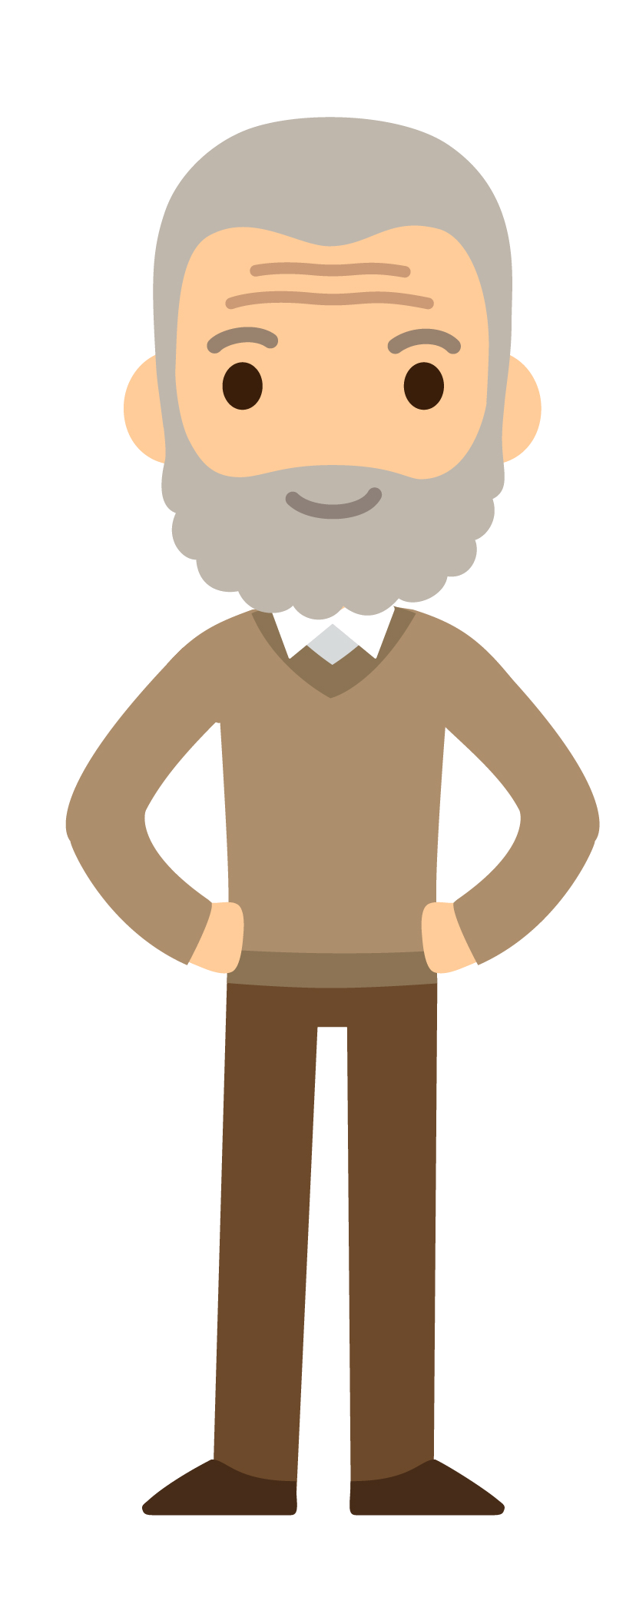
Danny – Danny is 52 years old and is a builder. He has had several incidents of back pain over the years but recently experienced pain that went down his leg. He worries about his back pain and his future.

Faye – Faye is in her sixties now and has had back pain for many years. She has found it hard to cope with her back pain at times but by getting to know herself she has developed ways to cope with the pain and feel more positive.

Get Moving, Know yourself, Tell others, Talk to your workplace
Most people will experience back pain at some point in their lives. This leaflet will tell you;
What back pain is; how it can affect your life; and what you can do about it
What causes my back pain?
There are lots of things that can lead to back pain such as poor posture, computer use, driving, lifting incorrectly and not being active enough. Very occasionally back pain is caused by an underlying condition and your doctor or therapist will consider this when they assess you.

How might it affect me?
Pain varies from person to person. For some it is severe and frightening, for others it is mild and familiar. For some it will get better quickly and for others it will stay persistent. Some people with persistent back pain may need additional help and support.
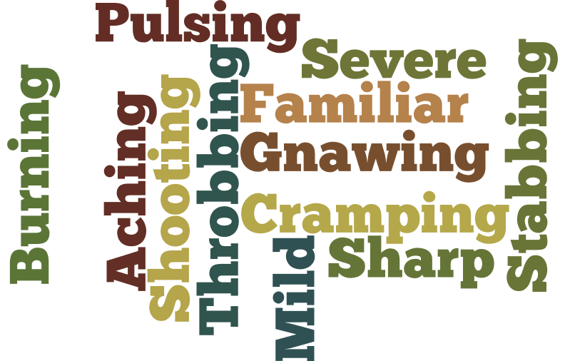

Navya says: “My back pain started years ago. It was a cold wet night and I had to stop the car to change a flat tyre far from home. I changed the wheel at the side of the road and then discovered that I couldn’t stand up straight again. Back pain is very common. A sore back may last for just a day or two. But a more severe episode can last for a few weeks or more and mine certainly flares and settles. There does not seem to be any pattern, sometimes I have no pain at all, but sometimes I have moderate pain.”

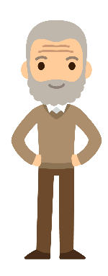
Danny says: “I was quite young when my back pain started, I think it was around about my late teens. I had a heavy, manual job at the time and it happened at work. Four of us had been tasked with carrying some heavy equipment through a narrow doorway, but it was awkward to manoeuvre and unfortunately the weight of the equipment shifted on to me when my back was bent. Since then I have had pain that comes and goes. Now it varies from a dull ache to full on pain, and I now get shooting, burning pain which goes down my leg. Life is not as happy as it should be because of the pain and although you learn to tolerate some of it, it can make me feel quite anxious and worried about the future.”

Does everyone feel back pain differently?
Yes and it affects various aspects of people’s lives.
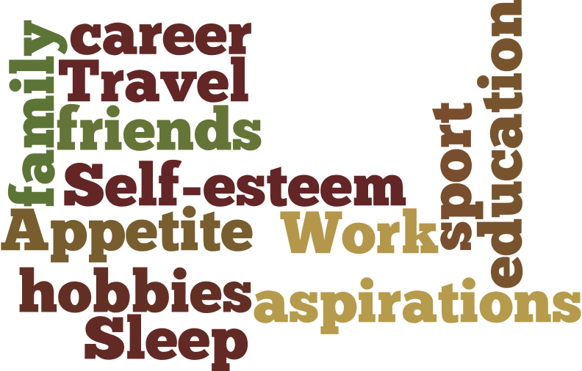

Mark says: “I had an episode of back pain recently when I woke up one morning and got out of bed. I felt sudden pain when I bent down to put on my slippers – it felt like a piece of elastic when the rubber perishes. It wasn’t excruciating but it was bad enough to make me wince – I understood exactly what people meant by feeling as if something had gone in my back. Every other person I speak to has some back pain, so it is very common but it affects some people more than others.

Faye says: “I was in a traffic accident when I was in my 20s. A motorbike hit me in my lower back. The pain generally reduced over time but I have been left with it long term. I now feel constantly uncomfortable and for several years the persistent pain affected both my career and my social life. My self – esteem plummeted and I felt lost and alone.”

What can I do about my back pain?
Although health care professionals will support you, the most important thing is for you to feel in charge of the pain and not let the pain be in charge of you.
There are many effective things that you can do to manage your back pain.

- Get Moving

It’s natural when back pain is bad for you to try resting or lying down, but it’s really important to get active again as soon as you can. Start gradually and don’t worry if it’s uncomfortable to start with. Remember hurt doesn’t mean harm.
Mark says: - “I understood that keeping active is crucial to recovery. I took painkillers at first but what really helped was that I kept moving by doing gentle stretching, strengthening my core muscles, walking and swimming and I think exercise also helps if you are feeling low from the pain. Being overweight can aggravate all kinds of problems, especially in your back, so I know now to keep my weight healthy. I have a desk job, so I made sure that I went for regular walks away from my desk. I still do this now!”

- Everyone is different

How you experience pain will depend on what’s going on in your life and how you are feeling generally. Being stressed, tired or feeling down doesn’t cause back pain, but can make it seem worse. Becoming more aware of these things will help you manage your pain better. So keep a diary and learn more about yourself.
Faye says: “Every person is different with their pain and how they deal with it. I have really had to get to know myself and listen to my body to understand my pain. I attend a local pain clinic. For me, learning to pace myself has been a huge help, I have to plan tasks and think of my limitations – I have to think before I act! The pain is annoying but I know how to manage it now. By learning about my back pain and knowing what I need to do, I feel like I am proactively doing something to help myself, which gives me a more positive outlook on my condition.”

- Telling others

It can be hard feeling that people may not believe you. Often there are no visible signs, however most people have had back pain at some point in their life and know what it feels like. Try to explain how your back pain affects your life.

Danny says: “Having back pain can make you feel very down and if you’re not careful you could feel isolated and it can be upsetting. But if you have support from family and friends it can help so much. It also helped me immensely to speak to other people who have been through the same as me.”

- Talk to Work

Getting back to work is important and you can talk to your workplace about this. It’s not necessary to stay off work until the pain has completely gone and your GP can give you a Fit Note that advises a gradual return with shorter hours or lighter duties.
Navya says: “I was worried about telling work, but my physiotherapist advised me to talk to my line manager and it went very well – I had my duties minimised after my initial absence to allow a mixture of activity and rest. This allowed me to do the essentials of my job whilst making a good recovery. I found the experience of seeing a physiotherapist excellent. I was given reassurance, advice and exercises to help my recovery.”

You may have some questions….
Having back pain can be upsetting and frustrating. You may have questions. Below are three of the most frequently asked questions about back pain and some advice for these. However, remember that your health care professional can answer your own personal questions.

- Do I need painkillers?

Painkillers are not a cure for back pain.
Talk to your pharmacist, doctor or nurse about which painkiller to choose in the short term to help you get moving again.
Long term and regular use of painkillers could cause harm, so remember - exercise works better.
Danny says: “A combination of a little bit of rest, exercise and painkillers worked for me. I feel it’s important to keep moving as much as I can, I watch my posture and generally think about what I am doing more. Mostly I just get on with it.”

- Do I need tests?

Your doctor or health care professional can assess you properly by listening to your story and by examining you. Usually this is enough without doing further tests to work out how best to help you and is more important than a scan.
The back is made of many things such as bones, discs, ligaments and nerves and all of these can be the source of pain, often in combination, but this doesn’t always show up on tests.
What’s important now is that you invest your energy into helping yourself manage and cope with the pain.

Navya says: “I went to the doctor who examined my back and listened to me talk. She said that tests are only needed if a fracture or something more sinister is suspected, so I knew that x-rays or blood tests were not going to help.”

- Why has my back pain lasted for months?

Your back pain is not getting better and your doctor or physiotherapist has reassured you there’s no underlying spinal condition. You are not alone. Many people with back pain find it persists long after that first episode. Like you, many people find the pain is still stopping them doing the things they’d like to do or they enjoyed doing before the back pain.
The feeling of pain takes place in the brain’s pain centre and acts like a burglar alarm. It sends out loud signals if it gets disturbed, so that you can take action.
But like a burglar alarm, the pain centre can go wrong and can go on producing pain even if the source of pain has gone away. It is important that you keep active and try to do and enjoy things because this helps to ‘re-set’ the pain centre. You will not be harming your back by doing this even If you still have pain.
Hurt doesn’t always mean harm. There is no quick and easy way to switch the pain centre off, but over time, you can reset and quieten it down. There are health care professionals who can help you with this.
REMEMBER: Contact your health care professional if you feel things
aren’t going according to plan

Further information:
https://startback.hfac.keele.ac.uk/
@KeeleStartBack @Keele IAU
You may find these YouTube videos helpful.
Scan your smartphone over the QR codes to go directly to the videos.
The advice contained in this leaflet has been developed in keeping with NICE guidance and is NICE endorsed. It has also been commended in the 2019 BMA awards.
This leaflet has been designed by patients who are part of the LINK group, Impact Accelerator Unit, at the Research Institute for Primary Care and Health Sciences, Keele University, UK Email health.iau@keele.ac.uk for more information ©Keele University 2019 V3.2 Review Date: 29/3/2020

